User Manual
Installation of Xubuntu Linux on Oracle VirtualBox

Student Information
- Name: Muhammad Saim Naveed
- Roll No: 24F-3043
- Course: Operating Systems (Lab)
- University: FAST NUCES

1. Introduction
Linux is an open-source operating system used widely in academia and industry. Xubuntu is an official lightweight flavor of Ubuntu that uses the XFCE desktop environment. It is designed to perform efficiently on systems with limited hardware resources while maintaining stability and security.
This manual explains the complete procedure for installing Xubuntu Linux on Oracle VirtualBox, along with the installation of required compilers. The setup enables safe experimentation with Linux without modifying the host operating system.

2. Why I Chose Xubuntu and Oracle VirtualBox
I chose Xubuntu instead of Ubuntu because Xubuntu is a lightweight Linux distribution that uses fewer system resources. It runs faster and more smoothly on systems with limited RAM and processing power. Despite being lightweight, Xubuntu is based on Ubuntu and uses the same repositories, security updates, and package management system. This makes it ideal for academic lab work without compromising stability.
I chose Oracle VirtualBox instead of VMware Workstation 17 Pro because VirtualBox is completely free and open-source, making it suitable for student and educational use. VMware Workstation Pro requires a paid license, which is not always accessible for students. VirtualBox provides all the essential virtualization features needed for operating system labs, such as virtual machine creation, snapshots, and hardware configuration, making it a reliable and cost-effective choice.
Conclusion: Xubuntu provides the benefits of Ubuntu while being more efficient and suitable for academic lab environments.

3. Why Oracle VirtualBox Instead of VMware Workstation 17 Pro
Oracle VirtualBox was selected over VMware Workstation 17 Pro for the following reasons:
- Free and Open-Source
Oracle VirtualBox is completely free for educational use, whereas VMware Workstation Pro requires a paid license.
- No License Restrictions
VirtualBox can be installed and used without activation or license expiry issues.
- Easy Installation
VirtualBox is simple to install and configure for beginners.
- Better for Academic Use
It is widely recommended in university labs due to its accessibility.
- Sufficient Features
VirtualBox provides all necessary virtualization features such as snapshots, shared clipboard, USB support, and networking.

4. System Requirements
Hardware Requirements
- Minimum 4 GB RAM (8 GB recommended)
- Minimum 20 GB free disk space
- Virtualization enabled in BIOS
Software Requirements
- Windows 10/11 (Host OS)
- Oracle VirtualBox
- Xubuntu ISO Image

5. Required Software
- Oracle VirtualBox
- Xubuntu ISO (64-bit)
- GCC Compiler

6. Step 1: Download Oracle VirtualBox
- Open a web browser.
- Search for Oracle VirtualBox.
- Download the Windows host installer.
- Run the installer and follow on-screen instructions.
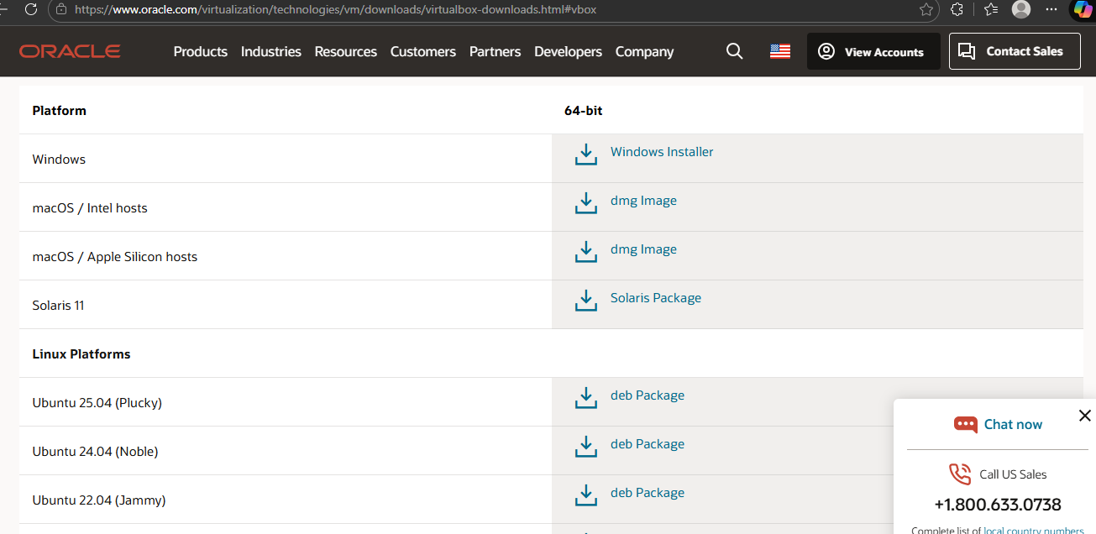
7. Step 2: Install Oracle VirtualBox
- Launch the setup file.
- Accept license agreement.
- Keep default installation settings.
- Complete installation.

8. Step 3: Download Xubuntu ISO
- Visit the official Xubuntu website.
- Download Xubuntu Desktop (64-bit) ISO.
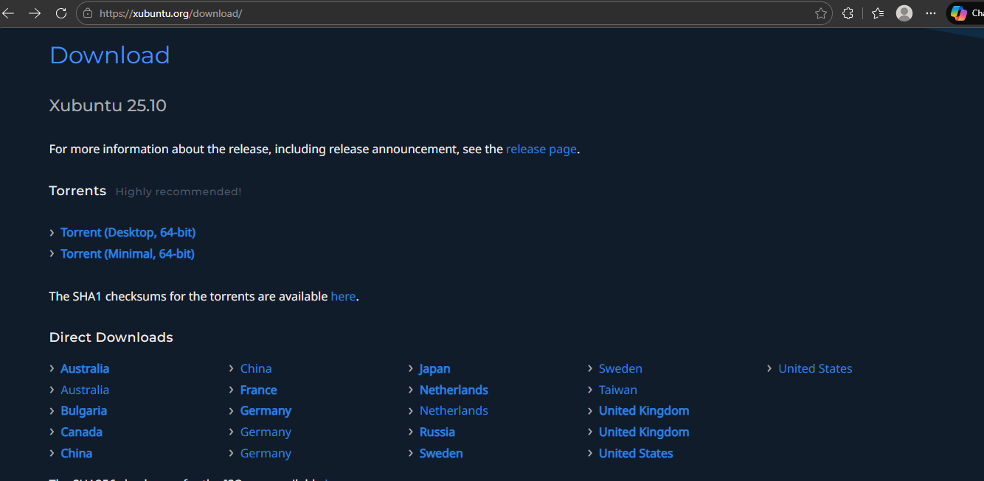
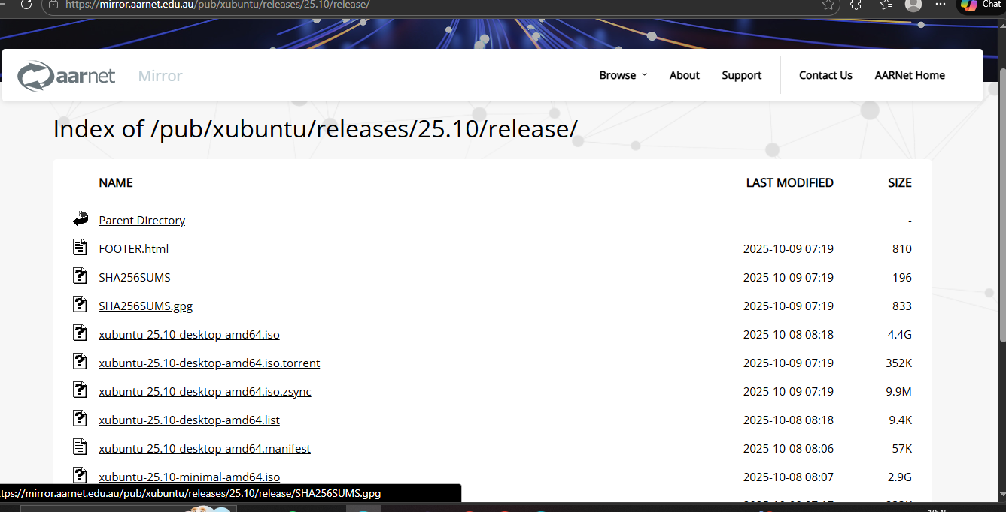

9. Step 4: Create a New Virtual Machine
- Open Oracle VirtualBox.
- Click New.
- Enter name: Xubuntu OS.
- Type: Linux, Version: Ubuntu (64-bit).
- Select Xubuntu ISO file.

10. Step 5: Configure Virtual Machine Settings
- Allocate RAM (minimum 2 GB, recommended 4 GB).
- Allocate CPU cores (2 recommended).
- Create virtual hard disk (VDI, dynamically allocated).
- Set disk size to 20 GB or more.
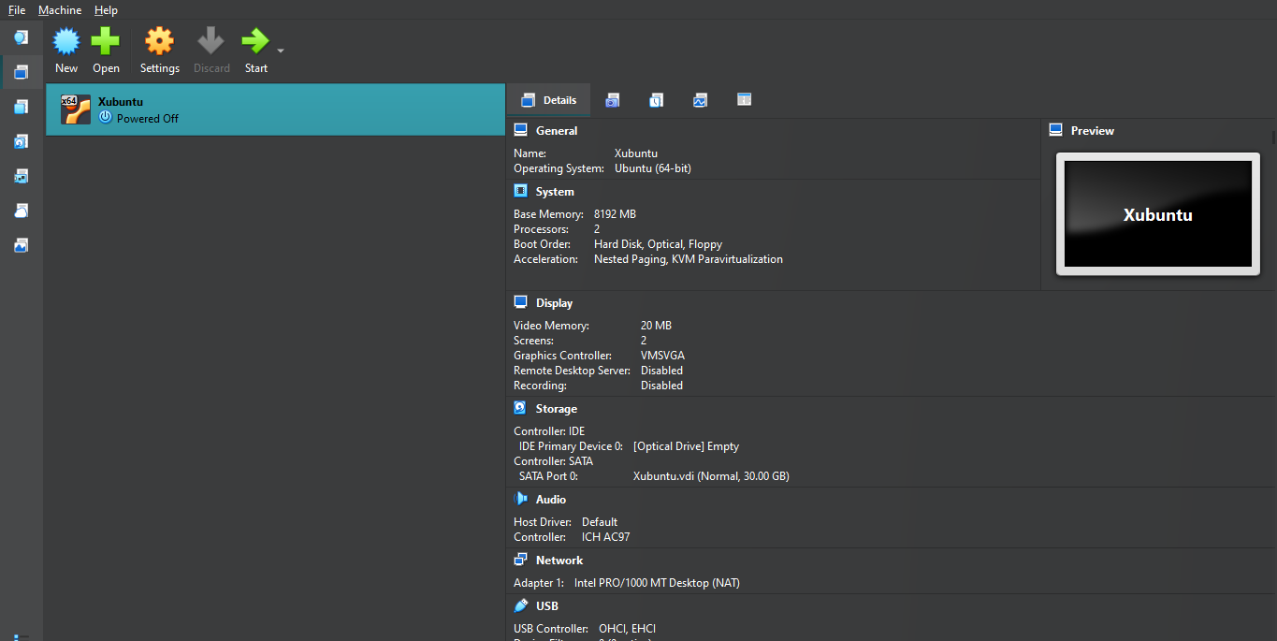

11. Step 6: Install Xubuntu
- Start the virtual machine.
- Select Install Xubuntu.
- Choose language and keyboard layout.
- Select Normal Installation.
- Enable updates and third-party software (optional).
- Choose Erase disk and install Xubuntu (safe in VM).
- Set timezone, username, and password.
Note: Xubuntu was already installed on the system, so there was no need to install it again. The relevant screenshot is provided below.

12. Step 7: Xubuntu Desktop Successfully Installed
- Restart the virtual machine.
- Log in using credentials.
- Xubuntu desktop appears.
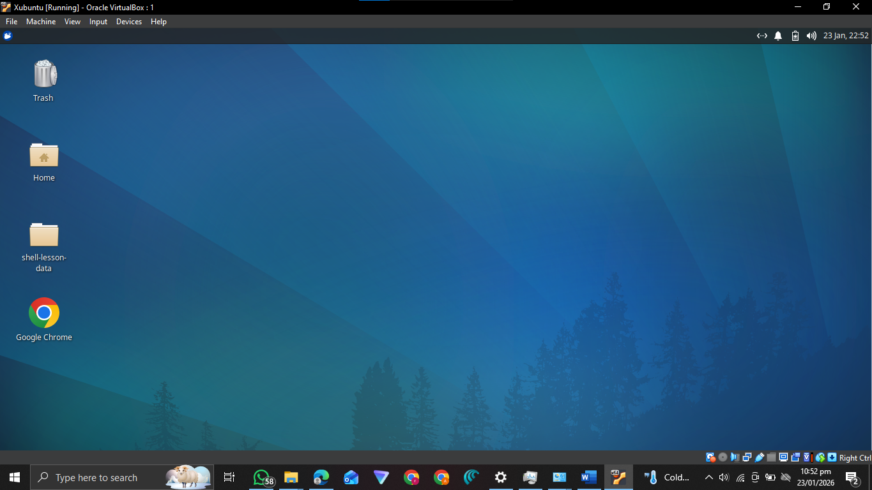
13. Step 8: Update System Packages
Open terminal and run:
sudo apt update
sudo apt upgrade
📸 Screenshot 8: System Update Output

14. Step 9: Install Required Compilers (GCC)
Install build tools using:
sudo apt install build-essential
Verify installation:
gcc --version
g++ --version
Compilers Installation
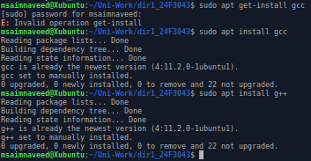

Note: I already have xubuntu installed in my laptop because ubuntu is heavier and consumes much resources.
Xubuntu is the same as ubuntu, only default apps differ slightly (lighter apps in Xubuntu).

15. Step 10: Testing Compiler
Create a test program:
nano test.c
Write:
#include <stdio.h>
int main() {
printf("Hello Xubuntu!\n");
return 0;
}
Compile and execute:
gcc test.c -o test
./test
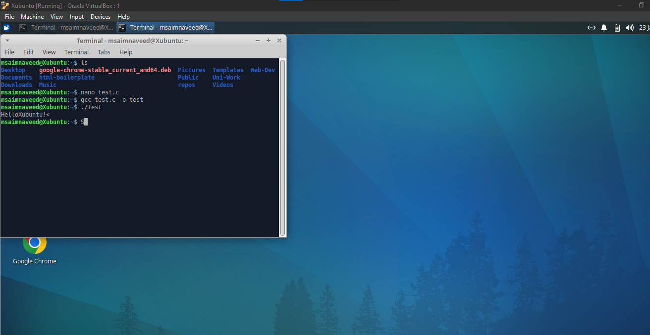
16. Conclusion
Xubuntu Linux was successfully installed on Oracle VirtualBox, and required compilers were configured. Xubuntu’s lightweight nature makes it ideal for academic use, especially on systems with limited resources. Oracle VirtualBox provided a free and efficient virtualization solution for this setup.

17. Learning Outcomes
- Understanding lightweight Linux distributions
- Installing Xubuntu on Oracle VirtualBox
- Virtual machine configuration
- Compiler installation and testing
- Basic Linux command-line usage

End of Manual

